Topic 6 – Listening Beyond The Words The Third Option NoteSheet
[Introduction / Why We Stop Listening….]
- LISTENING is Absolutely Necessary in order to have a Healthy Relationship:
- "It is sad how quickly some couples move from the attentive unmarrieds to the preoccupied marrieds." - Ann Carroll

- Why do we STOP LISTENING to our spouse?
- We take each other for granted. We think we've heard it all before.
- Listening is hard work. It takes time, energy, effort. We get lazy.
- We're basically selfish and would rather talk about our own agenda.
- We don't want to hear truths which might be discomforting or painful.
- We figure all we’ll hear is nagging, criticism, complaints…

- What TRICKS do we use to AVOID Listening?
- The Put-off - "Later, later" - but later never comes.
- Monopolizing the discussion: constant talking and interrupting.
- Escapes - Alcohol/drugs, sleep, overwork, TV, sports, clubs, children, "puttering around with household chores," newspaper, etc.
- Distancing tactics - Emotional outbursts and attacks to scare off discussion and cut conversation short.
- Withdrawal - Sulking, walking out before a discussion is finished to avoid hearing what we don't want to hear.
If you want to avoid intimacy….
- BALANCE: There are 2 Unhealthy Ends of the COMMUNCATION BALANCE:

- Not Listening

- Not Speaking



- Balance – The Third Option – is COMMUNICATION:
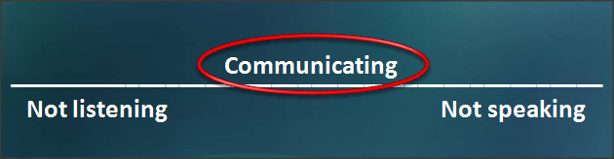
[Analogies / Problems]
- PROBLEMS which Interfere with Effective Listening:

- Scrambling: Our Defense Mechanisms can SCRAMBLE the message so we don’t hear painful or contradictory information. We THINK we are listening, but often DISTORT the message as we receive it:
- BLAMING
- Projection I read my own thoughts into what you say, or my own feelings of inferiority, guilt, fear, etc.

- Denial I just totally block out the truth because it is too painful (and I don't even realize I'm doing it.) Ex. "You're imagining things." “I’m NOT Yelling!”

- Rationalizing Making excuses. Ex. "It was only a white lie/small slap."

- STATIC:
- Poor concentration – Distracted, busy planning, worrying or having my mind on other concerns.

- Pre-judgments – I assume that I already know what you are going to say as soon as I hear the opening sentence or some key word. I jump to conclusions before you finish.

- Rebuttal — Probably the number one static. I'm busy thinking how to respond/defend myself or actually interrupting with my side.

[The Value of Listening]

- For any event or experience no two people experience it the same way.

A. PERCEPTION: You could say that there is 'HIS truth' and 'HER truth' and 'THE truth'.
THE (objective) TRUTH is probably in the middle part of what we experience.

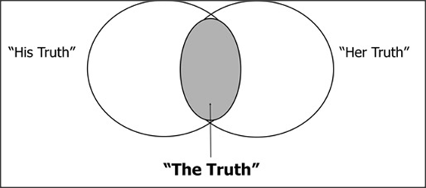
- Out of Body: To see how the world looks from SOMEONE ELSE’S POINT OF VIEW.

- Benefits: Listening is practically a miracle skill.
- It helps avoid misunderstandings
- keeps little issues from becoming big ones
- makes us feel closer / more loving
- Validates us as valuable or worthy
- Helps Avoid Fights
- Is Healing

- Goal: The goal of listening is understanding. No more no less. We can hear noise or a foreign language but it doesn't mean we understand.
Listening is about understanding feelings and meaning.

- Not to Solve: Listening may solve issues but the goal is merely understanding. We may still disagree and need conflict resolution. (another workshop….)

A Good Listener….

[Solution]

- Solution: the Reflective Listening Technique

A. The Technique
- Full Attention to Speaker

- Reflect Back

- Check for Accuracy

- Repeat 1 – 3, As Necessary (Until the talker feels they have been HEARD and UNDERSTOOD!)

- Reverse Roles: Listener & Speaker

Listening is not….

- SUMMARY: Listening is an important part of marriage. It is hard work to listen and for many reasons we may do less and less listening the longer we are married. Reflective listening can help.
The key ingredient in good listening is to be sure we have heard what the other person really said or meant. We cannot assume what we heard is what they said, or meant.

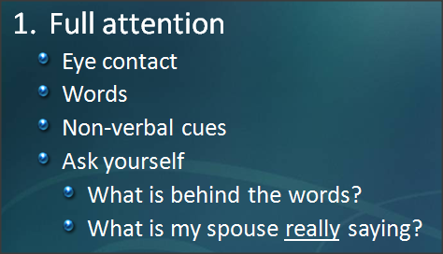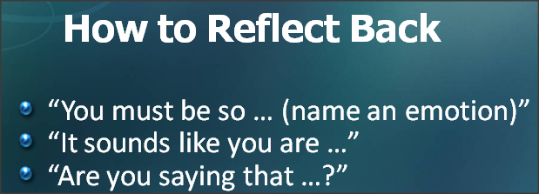

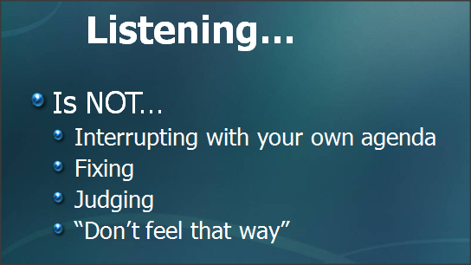

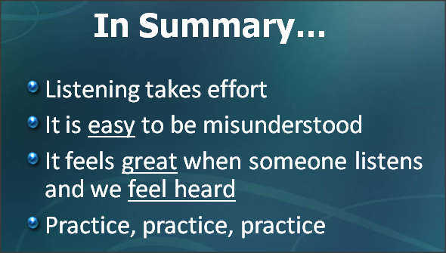

"Being heard is so close to being loved that for the average person they are almost indistinguishable."
- Augsburger

