Topic 5 – Control Issues The Third Option NoteSheet
[Introduction / Balance]
- CONTROL is closely related to POWER, but they are not quite the same thing:
- POWER is more about COMPETITION and WINNING - Our Right to consult on decisions that affect both of us.
CONTROL is more about AUTONOMY and Who CONTROLS ME, and WHOM DO I CONTROL. It is about our right to be DIFFERENT and to DISAGREE regarding our personal decisions.

- Our CONTROL CENTER can be Out of Balance in either of two directions:

- When we are NOT IN CONTROL: Whether because WE are OUT OF CONTROL, or SOMEONE or SOMETHING ELSE is controlling us.

- On the other side, we can be TOO CONTROLLING – OR TOO CONTROLLED: Too Rigid; need things to be Too Predictable; and/or be Very Controlling of OTHER PEOPLE.

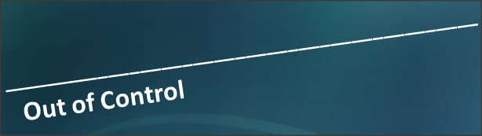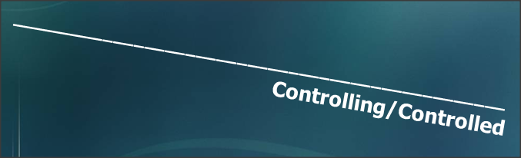

Neither of these is healthy to a marriage. In fact, we have NO RIGHT to CONTROL each other!

Marriage is a working partnership - but we both are still free adults and can - and should - be in control of ourselves and only ourselves.

The Third Option, then, is two autonomous people in self-control:

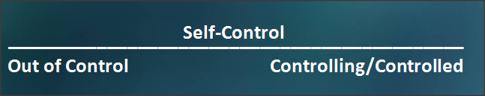

[II. Run-away Car]
- Out-of-Control Key Points:
- When we feel “Out-of-Control,” and that no-one is in charge of our lives, we still find that:

- SOMETHING IS driving (just NOT us…), so the first Question is WHAT IS Driving (Controlling) Us?

- Time (Management)
- FINANCES
- Emotions: Anger (“rageaholic”); hurt/self pity; fear….
- habits / addictions

- OR, perhaps we let OTHERS drive our life, in which case the Question becomes: WHO is CONTROLLING US? EXAMPLES:
- parents children
- our spouse boss / employer
- friends “peers”

How might others CONTROL us?
- bullying & Threats; intimidating; blackmailing; ultimatums
- manipulating - more Subtle, but very real: Playing on our EMOTIONS of pity, guilt, fear, sense of inferiority.

when we are not in control, something or someone else is!

- Solutions to being Out Of Control:
- Get Back in the DRIVERS Seat – That is: TAKE CONTROL
a. Shift Gears Slightly
b. Brake where necessary

- How can we do this with the THINGS that “Control” us? (Time; Finances; etc…)
  - Time: Shift Gears; Schedule Couple Time – talk time; date nights; Look for “Cheap Dates!”
  - Finances: Budget; Cut up Credit Cards
  - Emotions: Hold Tongue; Time Out;
  - Habits: Make Small Changes; ADDICTIONS: Self-Control WILL NOT WORK: Get help!

- How can we do this with PEOPLE?
  - Parents: They do NOT have the right to “consult”
  - Children: Read books / consult professionals – esp for Temper Tantrums, bedtimes, activities…
  - Boss: Decide as a COUPLE how much overtime & travel is OK, and what to do if job is in jeopardy
  - Friends / Peers / Others: Establish own / family / couple “moral compass”
  - Spouse: SEE BELOW!!

[III. Controlling – “Commander & Robot”]
- What does it look like when it is OUR SPOUSE who is Controlling us?
- We may act like a COMMANDER, and attempt to CONTROL our Spouse; or
- We behave as if we are a ROBOT, giving up all Control to our spouse.
Subtle ways in which we attempt to exert CONTROL:
- “Helpfulness” - Beware: If you are an “Atlas,” control is your middle name.
- HELPLESSNESS - Always having your spouse do (certain) things
- Sickly – Using Pity & Guilt to get what we want
- Surprises – Example: Tax Refund & Computer
- Overly Sensitive - Prone to “moods”
- Worrier – If you identify yourself as a worrier, you are controlling because this makes you feel secure.

- How might the person who plays the “Robot” in a relationship feel?
- Controlled Nagged
- Boxed in Angry
- Powerless Inferior
- Small Stupid
- Used Like an Object
- Unappreciated Like a Child
- No Identity Controller is a “Bad Person”

- What might the “Robot” be ANGRY About?
- At SPOUSE for Controlling them; BUT….
- Also AT THEMSELVES for NOT STANDING UP for Themselves!

IF we are letting someone control us, we are part of the problem: No one can control us unless we let them.

- HOW might the Controlled Spouse FEEL if they attempt to exert Independence?
- Released In Control
- Free Exhilarated
- Proud Scared (!)

- WHAT might the Controlled Spouse FEAR if they attempt to exert Independence?
- Fear of what may happen to the RELATIONSHIP. (This fear may well be why they permitted themselves to be controlled in the first place.)

- How might the person who plays the “Commander” in a relationship FEEL?
- Important Superior
- In Control Smug

But Also:
- Uncomfortable Ashamed
- Guilty
HOW might the Controlling Spouse FEEL if their partner attempts to exert Independence?
- Upset Ignored
- Hurt Angry
- Anxious Panic

And what might they FEAR under this change in circumstances?
- Fear of what may happen to the RELATIONSHIP.
Often we let others control us and we try to control others for the same basic reason: We are afraid! Control issues are very closely related to needs for security and feelings of safety.

- Solutions for Control Issues:

    - SELF-CONTROL: The Solution for ALL of these problems – Out-of-Control, Being Controlled, and Controlling – is the same: SELF-CONTROL.
Remember: We can only CHANGE OURSELVES, because ultimately we only have CONTROL over ourselves.
    - Controller (Commander):
Remember: Controlling is only an ILLUSION. By attempting to control others, we usually drive them away. Instead, we need to learn to state our preferences, and if our spouse still chooses another way, just say “Whatever” and let it go. (DISCLAIMER: Immoral, Unethical, Illegal, Too Expensive….)
(If our spouse's life is like a run-away car, then we are passengers in the same car! After all, marriage is a partnership, we are in this together! We cannot control our spouses: Detach yourself from their Destructive behavior, if necessary. Take care of yourself / children, and be in control of YOUR life. Get Help & Support, and seek to obtain same for your spouse.)
C. Controlled (or OUT OF CONTROL) Person (Robot):
The only solution is to begin to CONTROL YOUR OWN LIFE.
- Get Help: Counseling or “12-Step” program, as appropriate.
- Remember: Some of the Anger which you think is at your spouse, is really at YOURSELF for NOT taking control of your own life.
Remember: Control is an ILLUSION: We can only be controlled if we allow it.
(It might also be helpful to remember that your spouse is not really such a "bad guy" either, just a little frightened. As you begin to take control over your life this is going to frighten your controlling spouse even more! It may help if you can reassure them that you still care about them, even though you may not do what they want you to do all the time.)

- Summary -
We need to control ourselves and only ourselves. This is a full time job. Then, allow our spouse to be themselves. That will endear them to us much better than trying to control them!

